**COST MONITORING DASHBOARD**

**FILTERS:**

* **DATERANGE(Default Filter)**
* **Connector_id(Custom Filter):**

Display Name :- Connector_Id

SQL Keyword :- Connector_Id

Role :- Analyst

Warehouse :- FIVETRAN_WH

Options Via :- Query

Write Query :- SELECT dISTINCT CONNECTOR_ID FROM FIVETRAN.FIVETRAN_LOG.CONNECTOR;

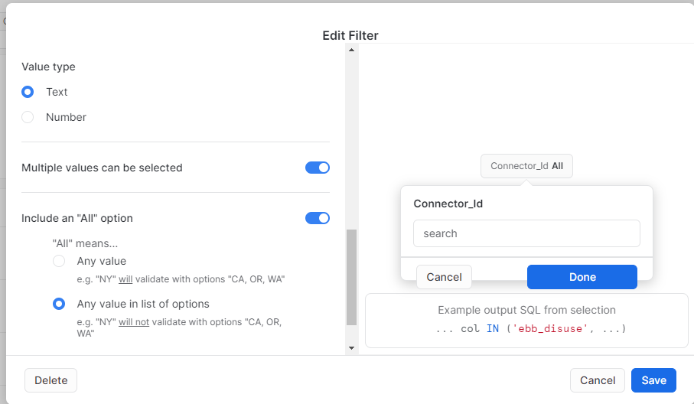

**3.1 Total Snowflake credit consumed by fivetran for cloud service**

select round(sum(CREDITS_USED_CLOUD_SERVICES),2)

from "SNOWFLAKE"."ACCOUNT_USAGE"."WAREHOUSE_METERING_HISTORY"

where warehouse_name ='FIVETRAN_WH' and START_TIME=:daterange;

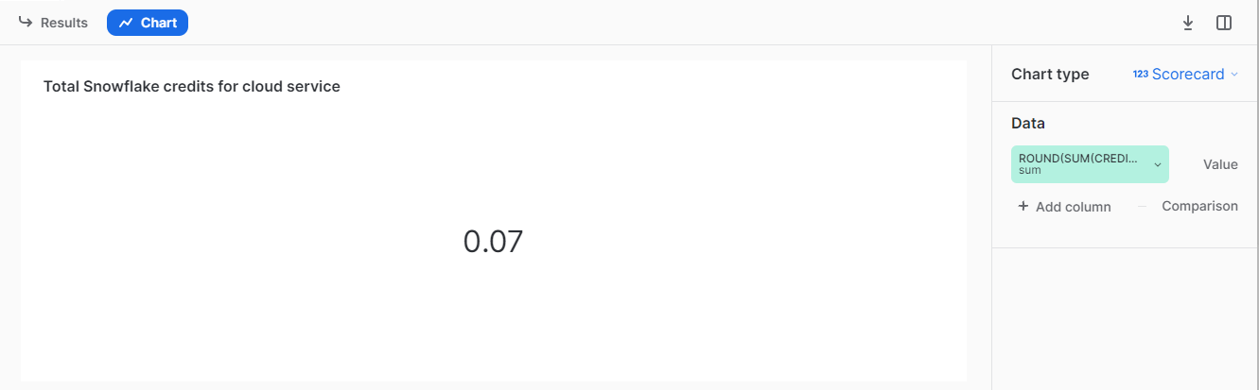

**3.2** **Total Snowflake credit consumed by fivetran for compute**

select round(sum(CREDITS_USED_COMPUTE),2)

from "SNOWFLAKE"."ACCOUNT_USAGE"."WAREHOUSE_METERING_HISTORY"

where warehouse_name ='FIVETRAN_WH' and START_TIME=:daterange;

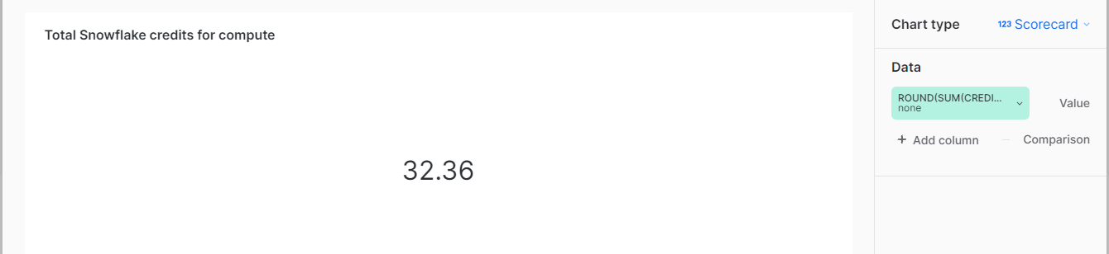

**3.3 Total Monthly Active Rows (Mar) In Millions**

select ROUND(sum(INCREMENTAL_ROWS)/1000000,2) AS MAR

from "FIVETRAN"."FIVETRAN_LOG"."INCREMENTAL_MAR" WHERE MEASURED_DATE=:daterange;

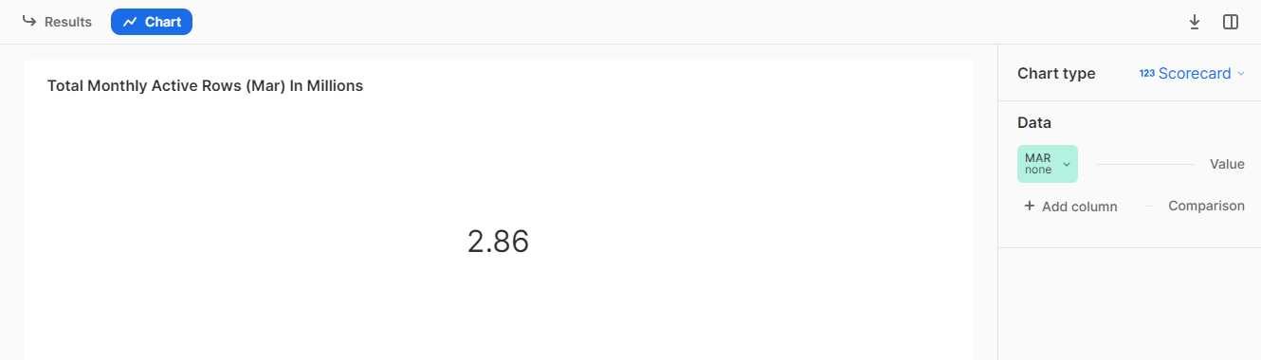

**3.4 Cost consumed by fivetran in $**

select sum(amount)

from FIVETRAN.FIVETRAN_LOG.USAGE_COST where measured_month=:daterange;

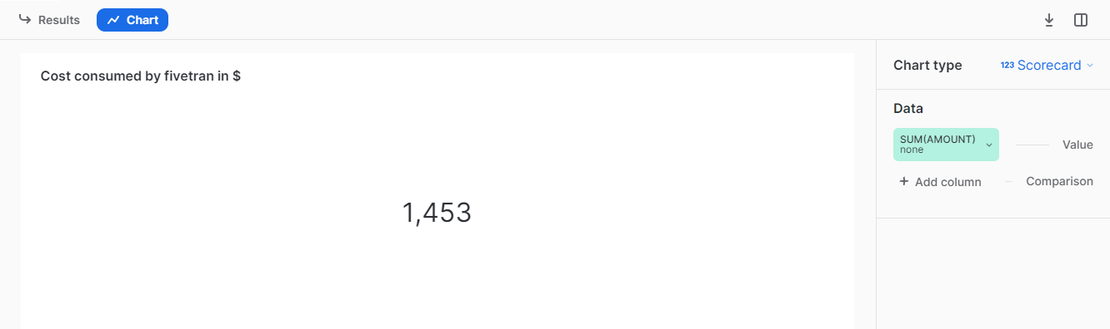

**3.5 Top 5 destinations with high cost consumption**

select TOP 5 destination_id,measured_month,amount

from FIVETRAN.FIVETRAN_LOG.USAGE_COST

where measured_month=:daterange;

order by amount desc;

SELECT DESTINATION_ID , (AMOUNT) FROM FIVETRAN.FIVETRAN_LOG.USAGE_COST

where measured_month=:daterange

order by amount desc;

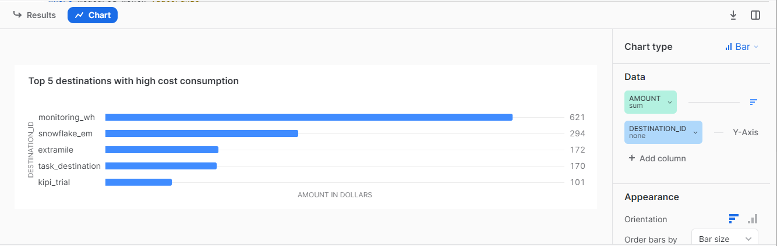

**3.6 Calculated MAR for each connector id**

select schema_name,

destination_id,

date_trunc('month', measured_date) as measured_month,

sum(incremental_rows) as MAR

from incremental_mar

where measured_date=:daterange

group by schema_name, destination_id, measured_month

order by measured_month, schema_name ;

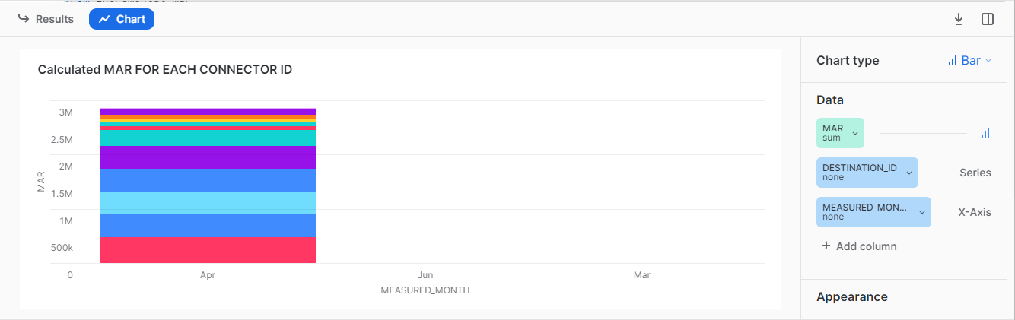

**3.7 TOP 5 SCHEMA WITH HIGHEST MAR**

select schema_name,

destination_id,

measured_date as measured_month,

ROUND(sum(incremental_rows)/1000000,2) as MAR

from incremental_mar WHERE MEASURED_DATE=:daterange

group by schema_name, destination_id, measured_month

order by MAR desc; schema_name;

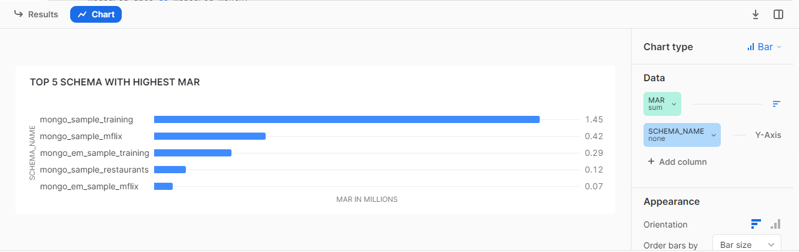

**3.8 Top 5 Schemas With No Of Records Modified Since Last Sync**

WITH parse_json AS (

SELECT

time_stamp,

PARSE_JSON(message_data) AS message_data,

message_event,

MAX(CASE WHEN message_event = 'sync_end' THEN time_stamp ELSE NULL END) OVER(PARTITION BY connector_id) AS last_sync_completed_at

FROM fivetran_log.log

WHERE message_event = 'records_modified'

OR message_event = 'sync_end'

)

select

trim( message_data:schema ,'"')as connector_schema,

MAX(time_stamp) AS last_records_modified_at,

SUM(CASE WHEN time_stamp > last_sync_completed_at OR last_sync_completed_at IS NULL THEN message_data:count::integer ELSE 0 END) AS row_volume_since_last_sync

FROM parse_json

WHERE message_event = 'records_modified'

GROUP BY connector_schema

ORDER BY row_volume_since_last_sync DESC

;

